**UNVEILING MARKET INSIGHTS: ANALYSING SPENDING BEHAVIOUR AND IDENTIFYING OPPPRTUNITIES FOR GROWTH**

1. **INTRODUCTION:**

**1.1 Overview:**

Wholesaling or distributing is the sale of goods or merchandise to retailer to industrial, commercial, institutional or other professional businessman to other wholesalers (wholesale businesses) and related subordinated services. In general, it is the sale of goods in bulk to anyone, either a person or an organization, other than the end consumer of that merchandise. Wholesaling is buying goods in bulk quantity, usually directly from the manufacturer or source, at a discounted rate. The retailer then sells the goods to the end consumer at a higher price making a profit.

**1.2 Purpose:**

Translating consumer insights and big data into concrete initiatives that drive market growth

1. **PROBLEM DEFINITION & DESIGN THINKING:**
   1. **Empathy Map:**

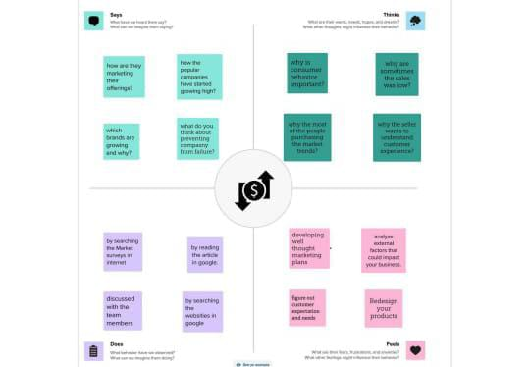

* 1. **Ideation & Brainstorming Map:**

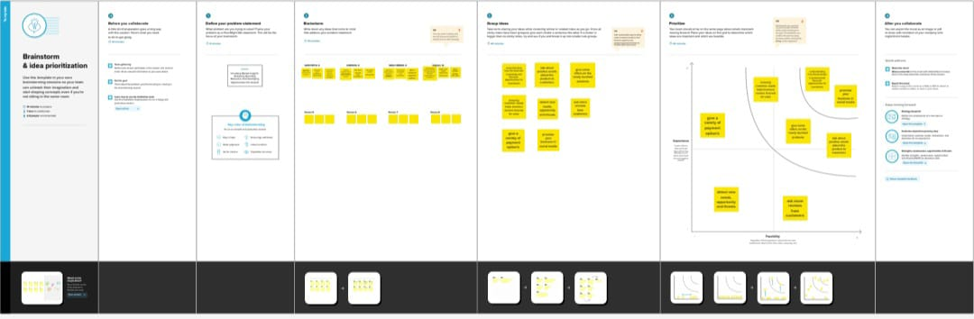

1. **RESULT:**

SHEET1

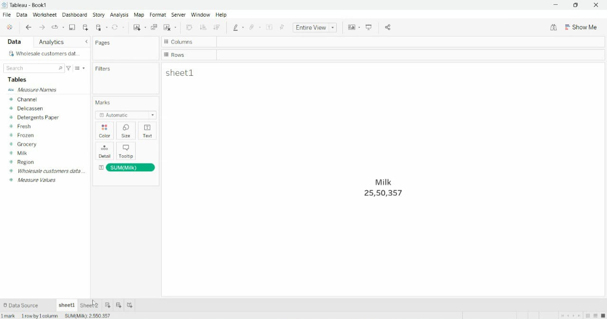

SHEET 2

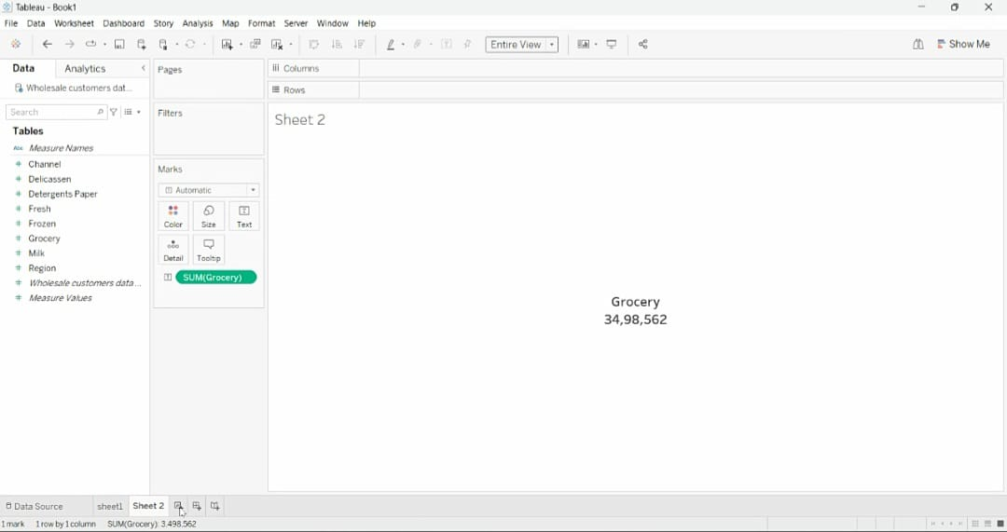

SHEET 3



SHEET 4

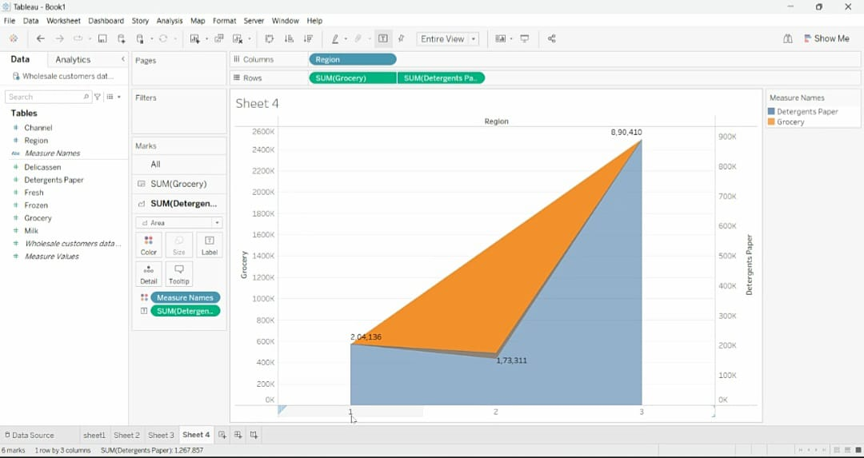

SHEET 5

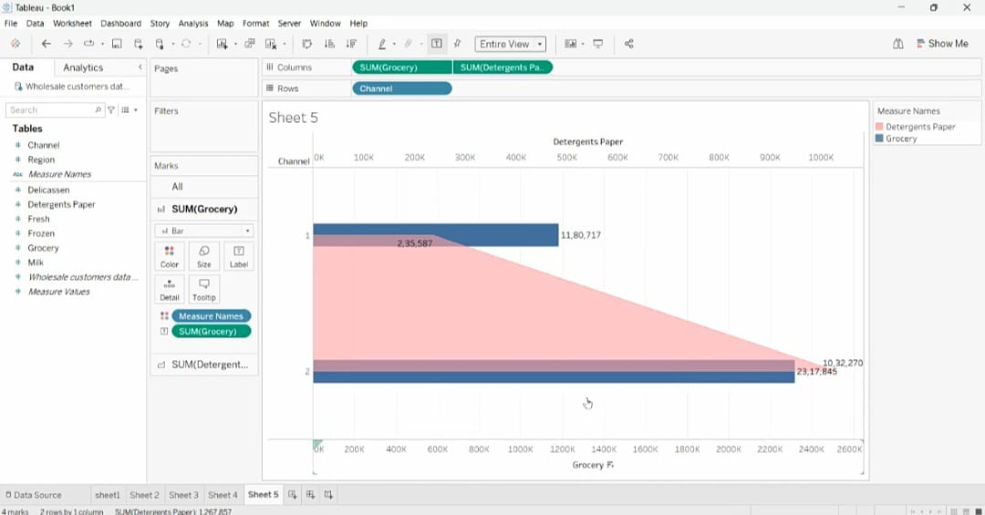

SHEET 6

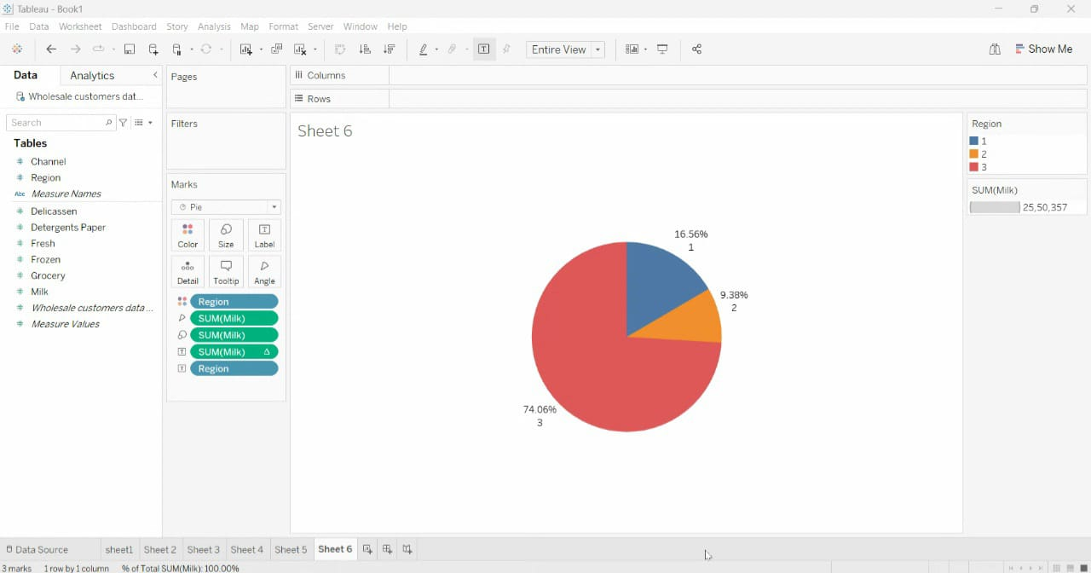

SHEET 7



SHEET 8

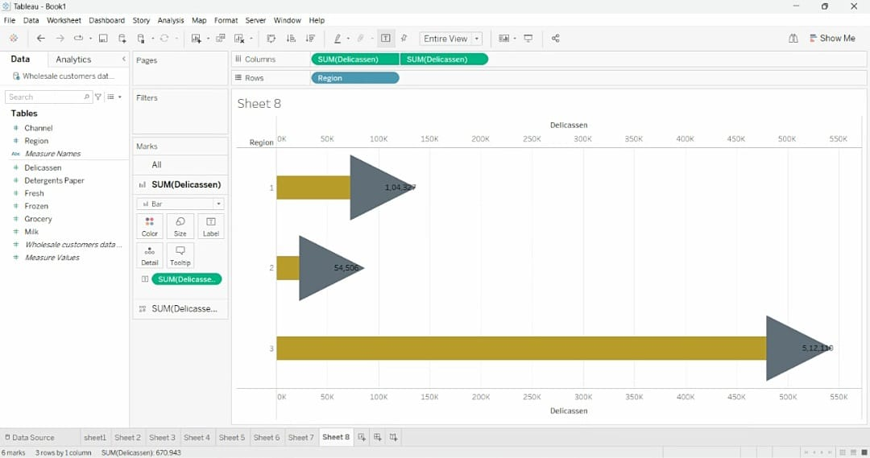

SHEET 9

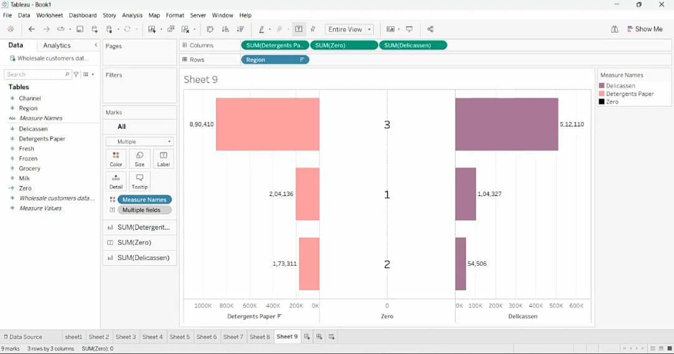

DASHBOARD 1

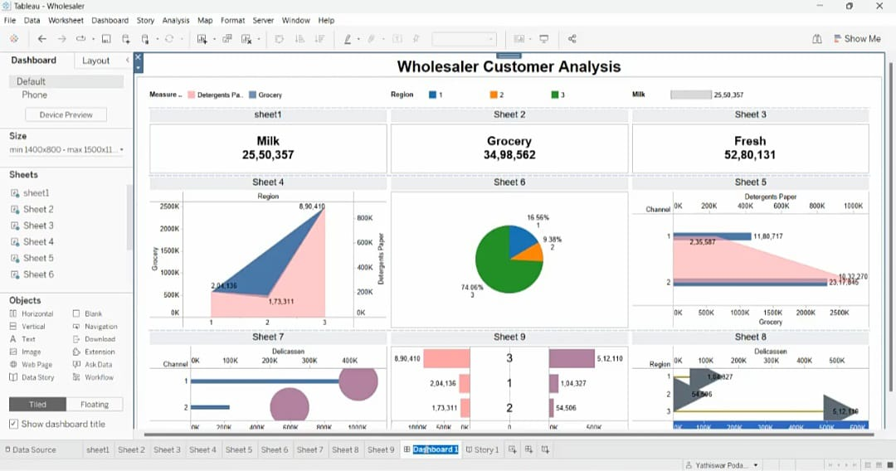

STORY 1

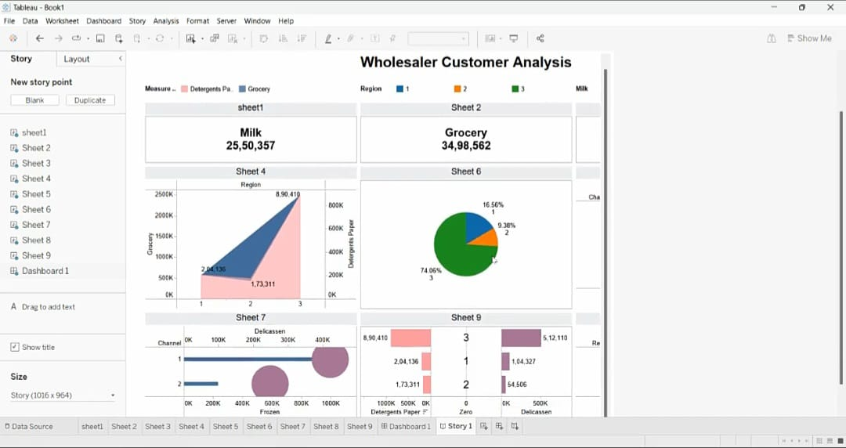

**4 ADVANTAGES & DISADVANTAGES:**

**ADVANTAGES:**

* It helps businesses strengthen their position.
* It minimises any investment risk.
* It identifies potential threats and opportunities.
* It helps to discover your’s and your competitor’s strengths and weaknesses

**DISADVANTAGES:**

* Risk of bias and subjectivity in the data collection and analysis process.
* There is a lot of competition. You may have to cope with tense deadlines.
* Informed decision-making, targeted marketing, and a competitive edge.

**5 APPLICATIONS:**

A company’s ability to drive above-market growth hinges on the depth of its consumer insights and how well it translates those insights into effective action. Our area of work is made up of more than 130 dedicated insights and analytics experts and professionals—with more than 900 years of collective experience in 12 countries and 25 cities across the world—focused on helping our clients do exactly that. To develop deep customer understanding, we employ a range of quantitative and qualitative marketing research approaches plus big data techniques that are both innovative and pragmatic.

**6 CONCLUSION:**

In the above discussion, we have tried to give you the details about marketing insight and its importance. One of the most important benefits of marketing insights we learned is that it will strengthen the relationship between marketers and customers by providing the details needed to solve marketing problems and assist with marketing policy. Understanding customer behaviour and attitudes are essential to developing effective marketing strategies.

**7 FUTURE SCOPE:**

The aim of market analysis is to identify the most important characteristics of a market and to determine the market structure at a certain point in time for products in a particular market. Market analysis provides businesses comprehensive information regarding the existing competition and consumer buying patterns. Businesses can also use market mapping tools to understand their position within a market**.**